Sheffield Inclusion Centre – 2025-2026

☻
We all have a statutory duty to “safeguard and promote the welfare of children” (Working together to safeguard children, DfE 2023 ) up to the age of 18 years.
If you have any concerns about the health and safety of a child or young person at this education setting or feel that something may be troubling them, you should share this information with an appropriate member of staff straight away.
Some issues such as a child’s appearance, hygiene, general behaviour, can be shared with any teacher or member of support staff in this setting. Do not worry about reporting small matters – we would rather that you tell us things which turn out to be small than miss a worrying situation.
However, if you think that a child, a young person or an adult who cares for them has been or might be harmed; please talk to one of the people below immediately.
You can ask any member of staff to find them and ask them to speak to you straight away about a confidential and urgent matter.

Our Designated Safeguarding Lead is:
Name: Trudi Eldridge
Their office is located next to - U34
Their tel. no is…01142531988 Ex 842
Email – Trudi.eldridge@inclusion.sheffield.sch.uk

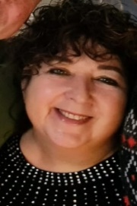

Our Designated Safeguarding Deputy is:
Name: Ash Khan
Their office is located next to - U02
Their tel. no 01142531988 Ex 858

Our Head Teacher is:
Name: Tuesday Rhodes
Their office is located next to - L13
Their tel. no 01142531988 Ex 854

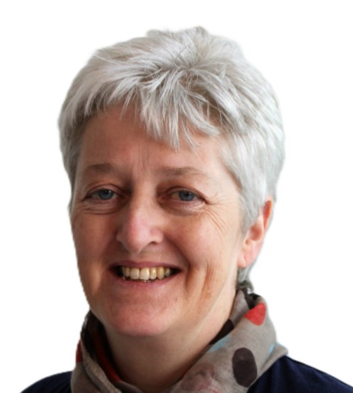
An allegation or disclosure of abuse involving someone working with children or adults in a paid or unpaid capacity must be reported directly to the Head Teacher, Senior Manager, unless it involves them and then it should be reported directly to the Chair Management Committee.
Name: Rhona Dodds - doddsr@hotmail.com
​

The Safeguarding Children Team in your setting includes:
Head Teacher: responsible for implementing policies & procedures, allocating resources to the safeguarding team & addressing staff safeguarding concerns.
Name: Tuesday Rhodes Tel no: 01142531988 – Ex 854
Designated Safeguarding Lead (DSL): teaching or pastoral staff from senior leadership team, responsible for all safeguarding issues, advising & supporting staff, liaising with the local authority & other agencies.
Name: Trudi Eldridge Tel no: 01142531988 – Ex 842
Designated Safeguarding Deputy (DSD): a teacher, support or pastoral worker, in a post which requires assessment of children, deputises for the DSL. Not an administrative or finance worker.
Name: Ash Khan Tel no: 01142531988 - Ex 858
Special Educational Needs & Disabilities Coordinator (SENDCo): support for pupils with special education needs & disabilities as well as their parents & carers, staff & other agencies working with said pupils.
Name: Katy Hodges Tel no: 01142531988 - Ex 846
Looked After Children Designated Teacher: promotes the education of ‘looked after’/previously ‘looked after’ children.
Name: Katy Hodges
Online-Safety Coordinator: develops & maintains a safe online culture within the setting.
Name: Trudi Eldridge
Safeguarding Support – trained safeguarding staff who are able to respond to safeguarding concerns if DSL, DSD and are unavailable.
Katy Hodges – Assistant Head – 01142531988 – Ex 846
Bridget Reaney – Safeguarding Officer – 01142531988 – Ext 834

Your Safeguarding Children Team also links in with the: Safeguarding/Child Protection Governor:
Ensures there are appropriate policies & procedures in place, that they are being implemented & followed, & challenges
deficiencies & weaknesses that are identified. Name: Rhona Dodds- doddsr@hotmail.com
Chair of Governors/Management Committee: Leads on safe recruitment & allegations of abuse against Head Teacher/
Principal/Senior Manager & other staff & liaises with Local Authority. Name: Rhona Dodds- doddsr@hotmail.com
​

