


Building Brighter Futures

Whistleblowing Policy for Staff in Schools

Date of policy | March 2013
Date approved | Autumn 2025
Date of next review | Autumn 2026
Signed | Management Committee

CONTENTS

Section 1 | Introduction | page 4
Section 2 | Raising concerns | page 9
Section 3 | Dealing with your concern | page 12
Section 4 | The investigation procedure | page 14
Section 5 | If you are dissatisfied | page 17
Appendix 1 | Examples of concerns that may be raised | page 18
Appendix 2 | Flow chart – reporting concerns through the  Whistleblowing Policy | page 20
Appendix 3 | Flow chart – managing a concern through the  Whistleblowing Policy | page 21
Appendix 4 | Useful contacts | page 22

PREAMBLE

This policy provides guidance for staff about how to raise concerns using the Whistleblowing Policy. It states their duty to report concerns whilst providing a framework in which those concerns can be raised. It also provides guidance for Headteachers, Chairs of Management Committee and line managers on how to manage the investigation of such concerns and the individuals who raise them.

[If you wish to report a concern about the local authority rather than the school, or you are employed by the local authority and are managing a concern made against it, please also refer to the Sheffield City Council Whistleblowing Policy, which is based upon the same principles as this document. This is available from Sheffield City Council Human Resources (0114 27 34299). Whilst the investigation will take place under the terms of that document, employees of Sheffield Inclusion Centre will still be protected under the terms of this policy.]

The Whistleblowing Policy has been designed for Local Authority maintained schools. Where an establishment which is not maintained but intends to adopt the content or principles of this policy, it is recommended that the establishment takes independent legal advice in order to gain clarity on any implications of the legislation and principles in this document. Any such establishment should also remove the sections highlighted in red, which relate specifically to Local Authority maintained schools.

SECTION 1 INTRODUCTION

The Management Committee of Sheffield Inclusion Centre adopted this policy for employees of the school on 2013.

The Management Committee will review annually.

1.1 Introduction

Most of us, during our working life, have concerns about what is happening in the workplace. Usually, these issues are easily resolved – but when they are about unlawful conduct, financial malpractice or dangers posed to people or the environment it can be difficult to know what to do next.

You may be worried about raising such concerns or you may want to keep them to yourself. Perhaps you feel the issue at hand is none of your business or that it’s only a suspicion for which you have little evidence. You may feel that raising the matter would be disloyal to colleagues, Management Committee, the Headteacher or the school. You may decide to say something but find that you have spoken to the wrong person or raised the issue in the wrong way and are not sure what to do next.

1.2 Purpose

This policy is designed to enable you to raise your concerns at an early stage and in the right way. As an employee of the school, it is your duty to raise these concerns. The Management Committee Sheffield City Council believe that helping you to do so is an important part of ensuring that the school is well-run and safe.

Providing the concern is genuine, the school would prefer you to raise it as soon as possible rather than waiting for proof; if it falls within the areas listed below, we ask that you do so using this procedure.

1.3 Application of the Policy

The Whistleblowing Policy is intended to cover genuine concerns that are not covered by other procedures and which you think the school or Sheffield City Council should look into.

Such concerns include:

- Unlawful conduct
- Financial malpractice
- Causing a danger to children and young people
- Causing a danger to staff, the public or the environment
- Contravening the Management Committee’s policies or the school’s code of conduct
- Deliberate concealment of any of the above

In Appendix One, we have provided some examples of the kind of issues the Management Committee would consider as malpractice or wrong-doing that could be raised under this policy. This should not, however, be regarded as a complete list – If you are in doubt about any issue, raise it.

1.4 Which concerns do not fall within remit of the policy?

The Whistleblowing Policy is primarily for concerns where the interests of other people or the organisation are at risk. It only applies if you are raising a concern in the public rather than your own individual interest.

If your concern is about your personal position in school or the way you as an individual have been treated, please raise it through the Grievance Procedure. A copy of this procedure is available in school.

Where a concern is raised about an individual or individuals, once the concern has been investigated under the Whistleblowing Policy, there may be a need for further investigation or action. This would take place within the framework of a different policy.
Where this is the case, you will be notified that the investigation under the Whistleblowing Policy has ended.

1.5 Your obligation to report concerns

As an employee of the school, the school’s code of conduct requires you to report genuine concerns of fraud, theft or unethical behaviour etc. This policy provides you with ways of doing that.

If you are concerned that a young person is at risk of harm, the guidance in the DfE’s
Keeping Children Safe in Education document and the Management of Allegations of Abuse (Schools) Policy obliges you to report your concerns. If you are concerned that a young person is being harmed or at risk of being harmed, or you have a concern about a staff member, volunteer or contractor’s suitability to work with children, you should report this using the Management of Allegations of Abuse Policy. If, however, you are concerned that:

- an individual’s professional practice, or
- the leadership and/or management of the school, or
- the school’s policies, procedures and/or ways of working

may be undermining the safety and wellbeing of young people, or leaving them vulnerable to risk, or you are worried about the way in which safeguarding allegations have been managed, you should express these concerns through the Whistleblowing Policy.

1.6 Our assurances to you

Your safety
The Management Committee recognises that the decision to report a concern can be a difficult one to make and the school and Sheffield City Council fully committed to the assurances given in this policy. If you raise a genuine concern under the
Whistleblowing Policy, you will not be at risk of losing your job or suffering any form of reprisal as a result. The Management Committee will not tolerate harassment, bullying or victimisation and will take action to protect you.

This protection applies not only while you are employed, but also after the working relationship has ended.

Provided you are acting in good faith, it does not matter if you are mistaken. However, if you maliciously raise a matter you know is untrue, disciplinary action may be taken against you in accordance with the school’s Disciplinary Procedure.

Confidentiality

While we will consider anonymous reports, this makes it much more difficult for us to look into the matter or give you feedback. However, the Management Committee recognises that you may wish to raise a concern in confidence under this policy. If you ask us to protect your identity by keeping it confidential, we will not disclose it as part of the Whistleblowing Investigation without your consent.

Please note, however, that the school will not tolerate the harassment, bullying or victimisation of anyone raising a genuine concern.

Please also note that any confidentiality clause within any other policy, agreement or contract should not prevent you from raising a genuine public interest concern under the Whistleblowing Policy.

Your right to support in meetings
In any meetings that have a connection to your whistleblowing concern, you have the right to be accompanied by your trade union representative or a work colleague (providing they are not involved in the issue and would not be called as a witness).

These meetings might include:

- A meeting with your line-manager or other appropriate person to raise your concern.
- A meeting with an investigation officer in connection with the concern.
- Taking part as a witness in any action taken as a result of raising the concern.

Contact details of trade union representatives can be found in Appendix Four.

1.7 Independent advice

If you are unsure whether to use this policy, or if you want independent advice at any stage, you should contact:

- Your trade union (contact details for which are provided in Appendix Four)
- The independent charity Protect which is a legal advice service which offers free confidential advice at any point in the process. Their helpline number is
20 3117 2520.

SECTION 2 – RAISING CONCERNS

2.1 How to report a concern

There are a number of different ways to raise a whistleblowing concern – you can choose the one that suits you. It doesn’t matter which you choose, you can be assured that a named manager will properly consider it.

Whichever way you decide to raise your concern, please ensure that you state that you are doing so under the Whistleblowing Policy. (If at any stage we feel that your concern is a grievance rather than a whistleblowing matter, we will tell you.)

Although you can raise your concern verbally, you may find it easier to do so in writing – this way, you can keep a record of what you reported as well as giving yourself the time to make sure you’ve included all the relevant information.

When reporting your concern, you should provide information about the background and history of your concern. Where possible, you should give names, dates and places and the reason why you are particularly concerned about the situation. If you are a member of a trade union, you may find it helpful to take advice from them about putting your concerns in writing.

There is no reason why you cannot use email to raise a whistleblowing concern. However, if you do choose to use email, please take extra care to make sure that your message is sent to the correct person and consider that due to the nature of email communication it may be read by other people. To help make sure your concerns are seen and handled quickly, mark the subject box: ‘Whistleblowing – confidential – recipient only’.

If, however, you do not wish to put your concern in writing, you can telephone or arrange to meet with the appropriate person.

2.2 Who to contact with your concern

Your supervisor, line manager or Headteacher

If you have a concern which you believe is covered by the Whistleblowing Policy, we hope you feel able to raise it first with your immediate line manager.

This may depend, however, on the seriousness and sensitivity of the issues involved and who you think may be involved in the malpractice.

For example, if you believe that your line manager is involved, you should approach the
Headteacher. If you believe the Headteacher is involved, your Chair of Management Committee should be approached and/or one of the LA officers named in Appendix Four.

If the concern is about the Management Committee or the LA, you can contact one of the named LA officers in Appendix Four. If it is about an employee of the LA, your concern will be investigated under the Sheffield City Council policy rather than the # School policy. This is because the school policy only applies to employees of # School; in the above circumstance, both the subject of the concern and the investigating officer are employed by the Council and are therefore covered by the Council’s policy. The protections set out in this policy will still apply, however, to school employees raising the concern.

The Council Monitoring Officer

If you feel the matter is so serious that you cannot discuss it with the Headteacher,
Chair of Management Committee or one of the named LA officers listed in Appendix
Four, you can raise your concern directly with the Council’s Monitoring Officer. The Monitoring Officer is responsible for ensuring that the Council, its members and its officers carry out their functions in a lawful and ethical manner.

External contacts

The school hopes this policy gives you the reassurance you need to raise such matters internally. If, however, you feel unable to raise your concern internally we would much rather you raise the matter with the appropriate agency than not at all. Provided you are acting in good faith and you have evidence to back up your concern, you can contact any of the following:

- Your local Council member
- Relevant regulatory organisations (such as the Department of Education)
- Your solicitor
- The police
- Other bodies prescribed under the Public Interest Disclosure Act.

If you do refer your concern to an individual or organisation outside the school or the LA, you need to ensure that you do not disclose confidential information. You should, therefore, first check with Legal Services, who will give you confidential advice – you do not have to give your name if you do not wish to. You will find a contact telephone number in Appendix Four.

SECTION 3 – DEALING WITH YOUR CONCERN

3.1 How the school will handle the matter

Once you have told us of your concern, we will look into it to assess what action should be taken.

In order to protect individuals, and the Management Committee and the LA, initial enquiries will be made to decide whether an investigation is appropriate and, if so, what form it should take. Concerns or allegations that fall within the scope of specific procedures (for example, child protection or discrimination issues) will normally be referred for consideration under those procedures. If your concern falls more properly within a different procedure, we will tell you.

Some concerns may be resolved without the need for an investigation.

The length of time it takes for us to respond will depend on the nature of the issue you are disclosing. If there is a safeguarding or health and safety risk, for example, we will contact you immediately. Whatever the nature of your disclosure, the Management Committee will write to you within at least ten working days to:

- Acknowledge that the concern has been received
- Indicate how we propose to deal with the matter
- Give an estimate of how long it will take to deal with the matter
- Tell you whether any initial enquiries have been made; and
- Tell you whether further investigations will take place, and if not, why not.

If a further investigation is required, this may involve:

- An internal investigation
- Referral to the police
- Referral to an external auditor
- An independent enquiry
The school or LA officer will tell you who is handling the matter, how you can contact them and whether further assistance may be needed from you.

3.2 Your right to the support of a trade union representative or colleague

When any meeting is arranged to discuss your concerns, you have the right to be accompanied by a trade union representative or a colleague (who is not involved in the area of work to which the concern relates and who also who could not be called as witness).

3.3 Our commitment to support you through the process

The Management Committee or LA will take steps to minimise any difficulties, which you may experience as a result of raising a concern. For instance, if you are required to give evidence in criminal or disciplinary proceedings, the Management Committee or LA will advise you about the procedure.

If you are asked to attend a meeting, we will aim to give you a minimum of ten day’s notice.

The Management Committee and the LA accept that you need to be assured that the matter has been properly addressed. Thus, subject to legal constraints and confidentiality, you will receive information about the outcome of any investigations.

SECTION 4 – THE INVESTIGATION PROCEDURE

4.1 Verification

Concerns raised under this procedure may be resolved by the person to whom they were reported. This could be your supervisor, line-manager or the Headteacher.

If they are not able to resolve the matter or you have raised your concern with the Chair of Management Committee , or a named LA officer, they will make initial enquiries to assess whether an investigation is required and, if so, what form that investigation should take.

If you did not raise your concerns directly with the Chair of Management Committee, unless the disclosure refers to them they will still be notified for monitoring purposes (see paragraph 4.4).

Although you are not expected to prove the truth of any allegation, you will need to demonstrate that there is a sufficient reason for expressing your concern. This policy provides protection to employees who raise issues in the genuine belief that there is serious cause for concern. If the complaint is found to be in bad faith, disciplinary action may be considered.

If it is confirmed that the Whistleblowing Procedure is the appropriate route and that an investigation is required:

- The concern will be recorded
- An Investigating Officer will be identified
- You will be told who will investigate and the likely timescale for the investigation within ten days

If there is insufficient information to make a decision about the most appropriate course of action, you will be asked for more information.

If it is decided not to investigate further, you will be told what enquiries have been made and the reasons for the decision.

When any meeting is arranged to discuss your concerns, you have the right to be accompanied as outlined in paragraph 3.2.

4.2 The investigation

The Investigating Officer may ask you to put your concerns in writing and provide as much evidence as possible. It may also be necessary to ask you to provide a witness statement. You will have the opportunity to confirm that the information you have provided is accurate and complete before it is used in the investigation.

You will be asked to agree that the information you have provided and your name may be disclosed so that the Investigating Officer can decide how the Management Committee and/or LA will respond and investigate the issue.

If you do not want to disclose your identity the Investigating Officer will decide how to proceed.

The Investigating Officer may need to contact you or other witnesses during the investigation.

The investigation will be carried out as quickly as possible but the time taken will depend on the nature of the issues raised and the availability and clarity of the required information. You will be updated at 28 day intervals unless this is not practicable.

If you are required to take part in the investigation you have the right to be accompanied as set out in paragraph 3.2.

4.3 The outcome

The investigation will be concluded with a written report of enquiries made, the findings on the strength of the evidence and whether the substance of the allegations has been established.

Where legal and confidentiality constraints allow, you will receive information about the outcome of any investigation. If the investigation continues within the framework of another procedure, the school will, if able, inform you of this.

If, however, the provision of further information would result in the school breaching an individual’s confidentiality or the law, we may not be able to you, as the person who made the disclosure, whether the investigation has continued under the framework of other policies since to do so may jeopardise the outcome of any further investigation. We will, however, inform you that the investigation is concluded under the framework of the Whistleblowing Policy.

If the investigation concludes that the allegations are not substantiated, the report will conclude whether the concerns were raised in good faith.

4.4 Monitoring

Within the school, a central record of all whistleblowing complaints, including dates, substantive issues, findings and outcomes is retained by the Chair of Management Committee. The Chair will report as necessary to the Management Committee in a way that maintains your confidentiality as far as possible.

SECTION 5 – IF YOU ARE DISSATISFIED
If you are unhappy with our response, remember you can use the other routes detailed in this policy in paragraphs 1.7 and 2.2.

While we cannot guarantee that we will respond to all matters in the way that you might wish, we will try to handle the matter fairly and properly. By using this policy, you will help us to achieve this.

APPENDIX ONE – EXAMPLES OF CONCERNS THAT MAY BE RAISED

This list shows the kind of issues that may be raised under the Whistleblowing Policy. However, there may be other concerns that can be raised under the policy that are not shown here; if you are aware of such an issue, please report it.

- Poor or unprofessional practice by a member of staff or an agency that results in the service user not getting the same quality of service which is available to others.

- Children or young people being put at risk by an individual’s professional practice, or the leadership and/or management of the school, or the school’s policies, procedures and/or ways of working.

- Allegations of a safeguarding nature not being taken seriously or appropriately handled.

- Improper/unacceptable behaviour towards employees, volunteers, contracted workers or service users which could take the form of emotional, sexual or verbal abuse, rough handling, oppressive or discriminatory behaviour or exploitative acts for material or sexual gain.

- Any unlawful activities, whether criminal or a breach of civil law.

- Fraud, theft or corruption.

- Concerns regarding possible breaches of Health and Safety regulations.

- Harassment, discrimination, victimisation or bullying of employees, volunteers, contracted workers and/or service users.

- Leaking confidential information in respect of Management Committee or LA activities or records.

- Misuse of pupil, employee, volunteer or financial data (including attainment information and personal details).
- Doing undisclosed private work which may conflict with working for the school or the Council, or which is being carried out during working time.

- Inappropriate contact with members of the public within school or Council facilities, or whilst carrying out school or Council duties outside of working time.

- Taking gifts or inducements.

- Inappropriate use of external funding or the school budget.

- Maladministration as defined by the Department of Education, Local Government Ombudsman or appropriate examination boards.

- Breach of any statutory code of practice.

- Breach of, or failure, to implement, or comply with any Management Committee policy.

- Misuse of school or Council assets, including, but not limited to, computer hardware and software, buildings, stores, vehicles and/or equipment.

APPENDIX TWO – REPORTING CONCERNS THROUGH THE WHISTLEBLOWING POLICY
____________________________________________________________________________________________________________

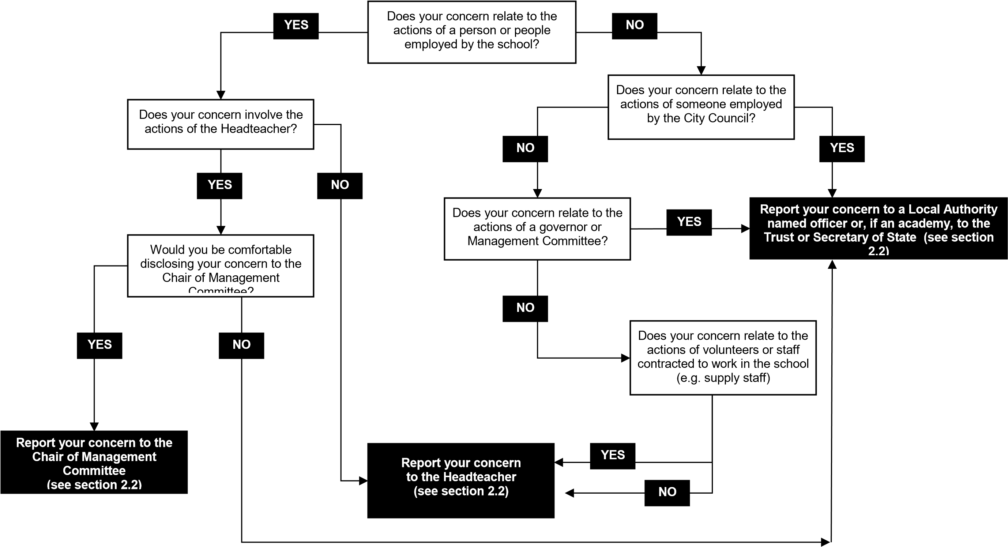

Model Whistleblowing Policy for Staff in Schools Mar 13 – updated Jan 24 20 of 22

APPENDIX THREE – MANAGING A CONCERN THROUGH THE WHISTLEBLOWING POLICY
_____________________________________________________________________

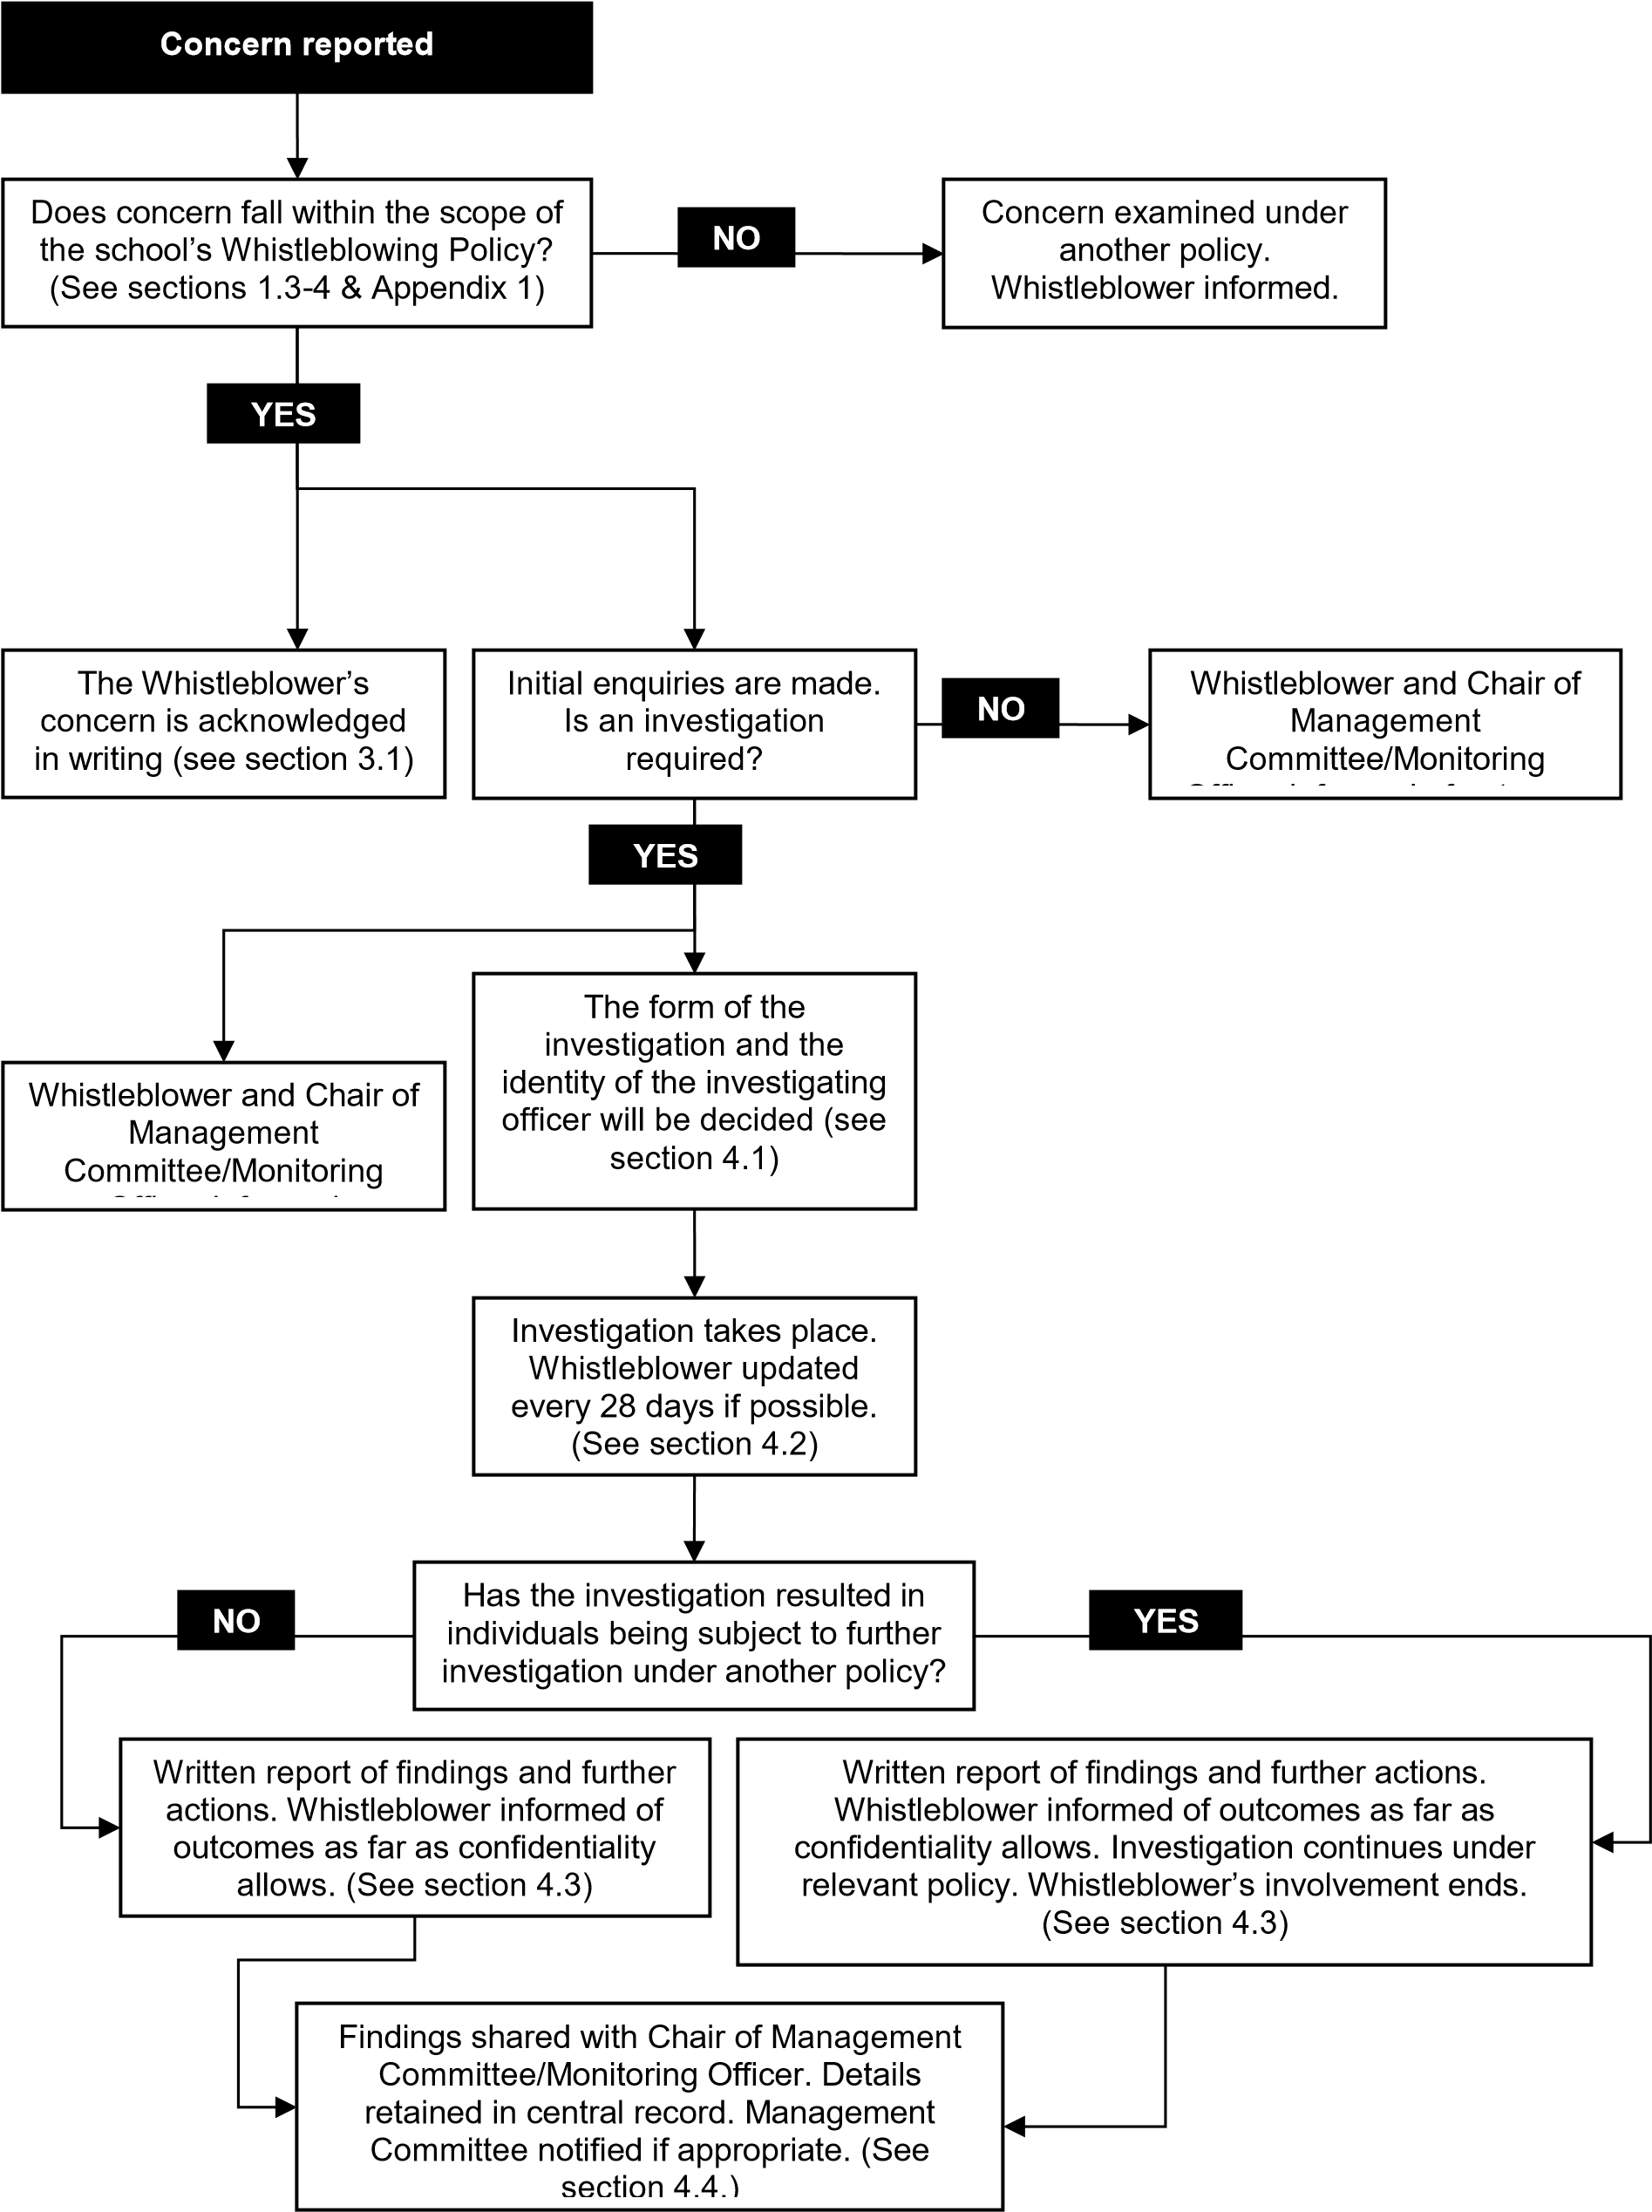

Model Whistleblowing Policy for Staff in Schools Mar 13 – updated Jan 24 21 of 22

APPENDIX FOUR – USEFUL CONTACTS

Please note that the contact details below are correct as of January 2024

Head of Human Resources
Elyse Senior Wadsworth
Elyse.Senior-Wadsworth@sheffield.gov.uk

Council Monitoring Officer David Hollis
david.hollis@sheffield.gov.uk

Internal Audit
Stephen Bower
Stephen.Bower@sheffield.gov.uk

Childrens Safeguarding
Amanda Boughton Brown
Amanda.Boughton-brown@sheffield.gov.uk

Adult Safeguarding
Tim Gollins
Tim.Gollins@sheffield.gov.uk

Trade Unions
ASCL |  | www.ascl.org.uk
GMB |  | www.gmb.org.uk
NAHT |  | www.naht.org.uk
NASUWT |  | www.nasuwt.org.uk
NEU |  | www.neu.org.uk
Unison |  | www.unison.org.uk
Unite |  | www.unitetheunion.org

Model Whistleblowing Policy for Staff in Schools Mar 13 – updated Jan 24 22 of 22

